**SharePoint 2016 Manual**

**Last Updated: 8/9/18**

https://officepoint.finance.nycnet/sites/taxauditandenforcementdivision/SitePages/Home.aspx

Contents

NOTES 2

Adding to a Library or List 2

For an existing Document Library, Read Here 4

Adding a Page 6

Text Layouts 7

Adding Document Library to a Page 8

Adding Custom Columns to a Library/ List 9

Adding Tabs to a Page Using Hillbilly Script 10

Adding Pictures to a Page 11

Adding Videos to a Page 13

Adding Tabs to the Top Navigation Bar 15

Dealing with Metadata 16

Updating What’s New 17

Adding Alerts 19

Deleting Alerts 20

Adding Keyword List 21

Creating a Custom Search for Keywords 22

Creating a Keyword Search List 24

Dealing with CSS 26

Adding Announcements 28

Adding and Removing Events on the Calendar 29

Creating Groups 31

Creating Custom Permissions for a Library 32

Setting a Target Audience 34

Configuring the Recently Uploaded Documents Web Part 36

How to Change the Overall Color Theme 38

To Change the Background to a Picture 39

To Change the Background to a Color Gradient 39

To Move Videos off the G Drive 40

NOTES

Anywhere in this manual that the word Insert is used, you must first click in the text box area to make the Insert menu option appear in the ribbon

In Site Contents, there are 2 folder called Site Assets: Site Assets(with 1 ‘s’) and Site Assetss(with 2 ‘s’). **DO NOT TRY AND DELETE OR COMBINE THESE LIBRARIES. KEEP THEM SEPARATE AND DO NOT TOUCH THEM.** The library with 2 ‘s’ controls all pages with videos on them.

# Adding to a Library or List

1. Before documents, pictures, or videos can be added to a page, they must be added to a library first
2. To add documents, videos or picture to a library
   1. 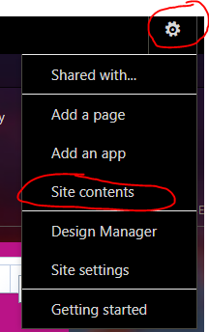Go to Settings 🡪 Site Contents
   2. 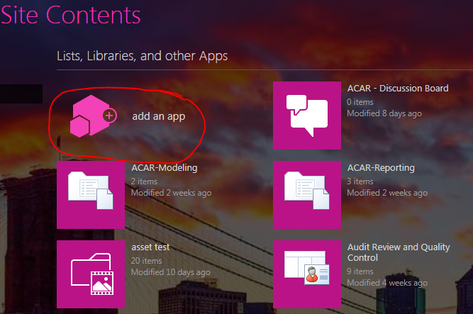Click Add an App
   3. 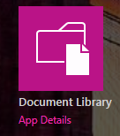 If you are dealing with documents, select Document Library
      1. 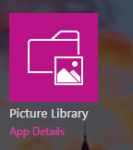If you are dealing with pictures, select Picture Library
      2. If you are dealing with videos, select Asset Library
   4. Regardless of content, you must now type in a name for the library
   5. You are now taken back to the Site Contents Page
   6. Find your Library and click it
   7. 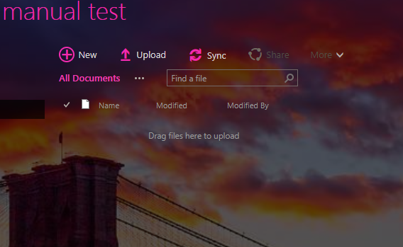You will see this page

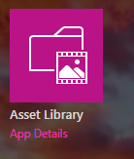

# For an existing Document Library, Read Here

* 1. To upload documents, pictures, or videos, they must be in one of these formats
     1. Word files: .doc, .dot, .dotx, .docx, .docm, .odt
     2. Powerpoint: .pot, .potm, .pps, .ppsm, .ppt, .pptm, .pptx, ppsx, .odp
     3. Excel .xls, .xlsx, .xlsm, .xlsb, .ods
     4. Pictures: .jpg, .png
     5. Videos: MUST be .WMV
        1. If they are not, use this converter to change the file type [https://video.online-convert.com/convert-to-wmv](https://video.online-convert.com/convert-to-wmv%20%20)
  2. If a document must be renamed, it must first be saved to your computer, renamed, and then uploaded to SharePoint
  3. 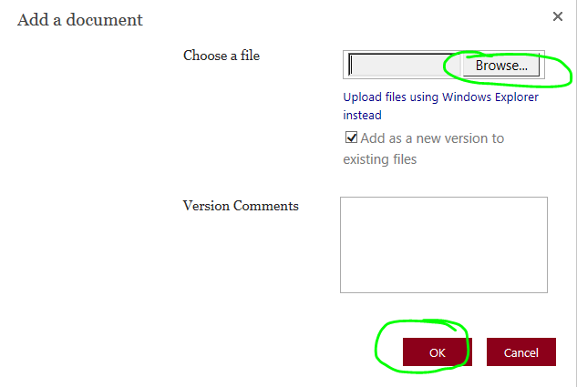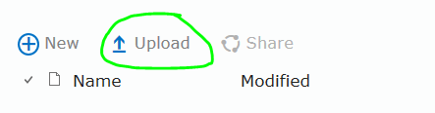Click the Upload button at the top of the library
  4. Click Browse to select a file and then click OK
  5. 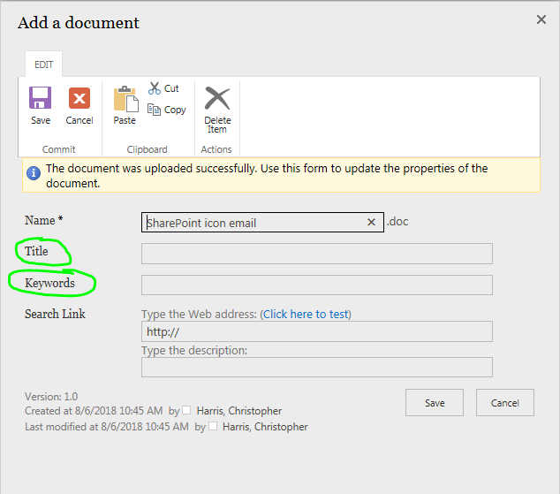Add the title and keywords for the document and click Save

Note: There is no longer a drag & drop feature on the site. All documents must be individually uploaded.

When you are done uploading documents, you must set the library to open documents in the browser, not on the client machine. To do this:

1. Navigate to the library. Then click Library 🡪 Library Setting
2. 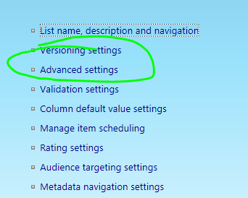Click Advanced Settings
3. Scroll down until you see Opening Documents in the Browser. Then select the second option 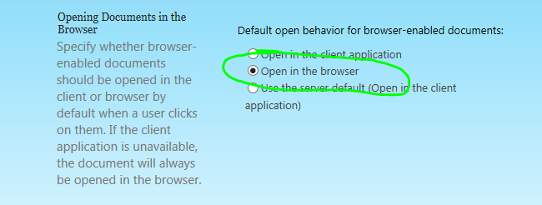

As of 8/10/18, all document libraries on the site are configured this way. This applies to any new document libraries created after this date.

# Adding a Page

1. 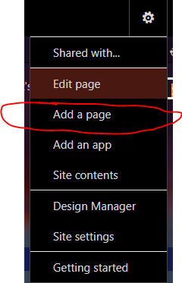Adding a page
   1. Click the Settings button in the top right corner
   2. Click Add a Page
      1. 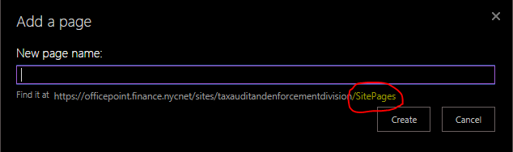The URL must end in …/SitePages

ii. If it does not, follow these steps but start from the home page

* 1. Type the name of the page and click create
  2. You must add a Script Editor, if needed, to the page and insert appropriate scripts. These can be found in the SharePoint CSS Manual which is on SharePoint.
     1. If you are making a page with document libraries on it, refer to CSS Manual page 3
     2. 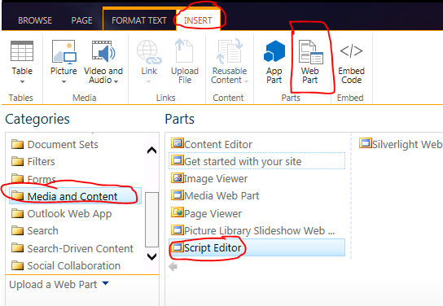Go to Page🡪 Edit🡪Insert🡪Web Part🡪 Media and Content🡪Script Editor
     3. Click Edit Web Part 🡪Edit Snippet
     4. Copy and Paste the Snippet from the CSS Manual that corresponds to the type of page you are creating
     5. Then Save the Page

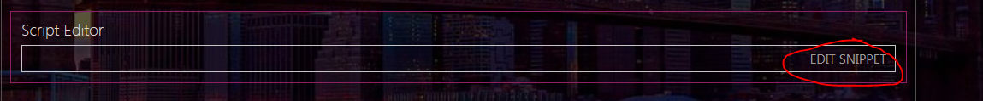If you are making a page for What’s New, go to page 17

# Text Layouts

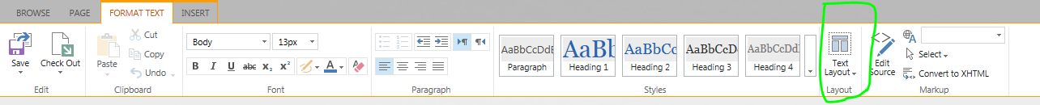There are various text layouts that can be selected for a page. These can be found by going to Page🡪Edit and then clicking text layout

Here are some reasons to use the specified layouts:

|  |  |
| --- | --- |
| Adding Videos to What’s New | Use 2 columns layout |
| Adding single pictures to a page | Use 2 columns with header/footer |
| Big blocks of text | Use 1 column |
| Adding picture slideshow alongside text | Use 1 column with sidebar |

# Adding Document Library to a Page

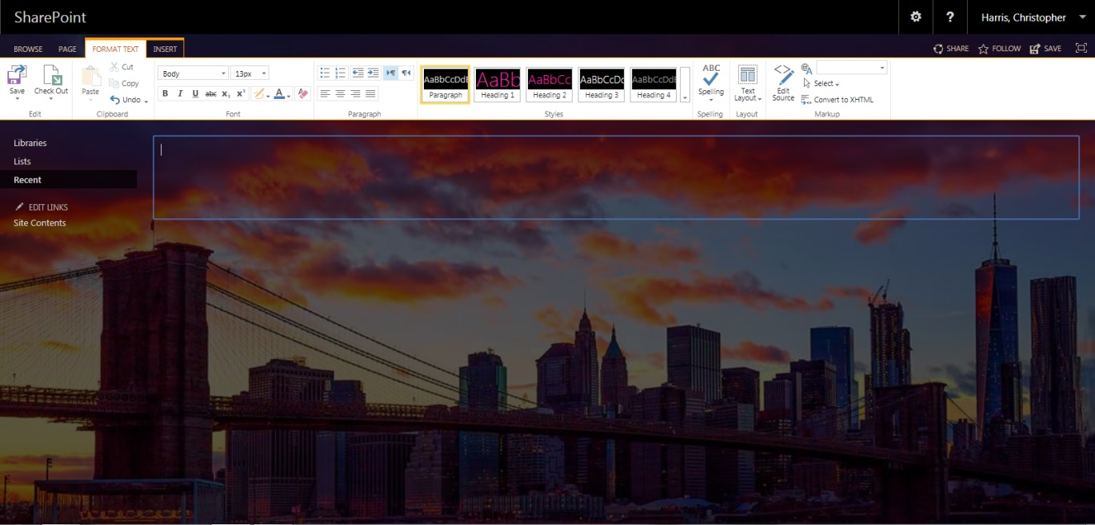

1. Go to the page where you want to add the list/library
   1. If there is no link for the page, go to Settings🡪Site Contents🡪Site Pages. Thenc click the name of the page.
   2. To add a library or list, click Page🡪Edit🡪 Insert 🡪 App Part
   3. 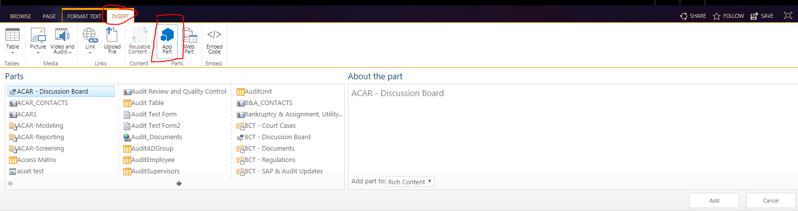Choose the library/list you want to insert and click add
   4. It will now be added to the page

# Adding Custom Columns to a Library/ List

1. 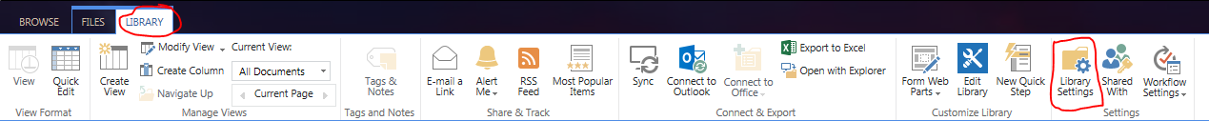Go to Site Contents 🡪 Click The Library/List you want to change
2. Click List/ Library 🡪 List/Library Settings in the top bar
3. 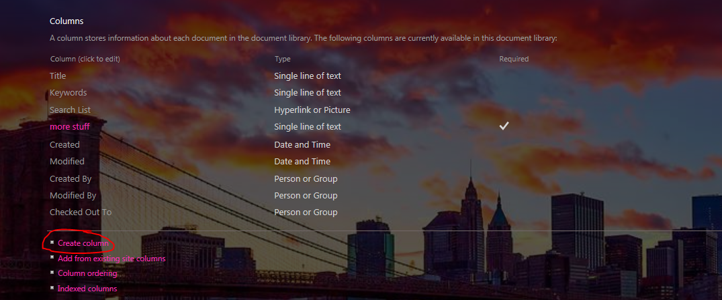Scroll down until you see the Column Section
4. Click Create Column
5. Enter a name and type for the column
6. 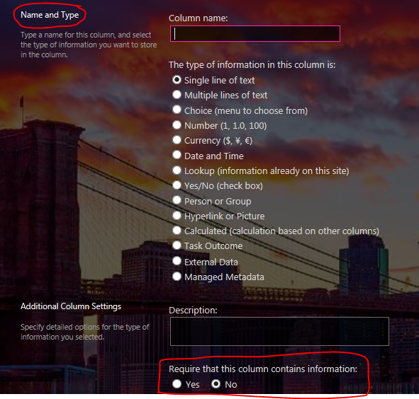If you want to make a column required, and force the uploader to enter a value for it at upload time, click the button that says Required Field
7. Click OK to save the column

# Adding Tabs to a Page Using Hillbilly Script

1. To Create Tabs on a page
   1. Have all the document libraries/lists created already
   2. On the page, place a Content Editor from the Web Part Option by clicking Page 🡪Edit 🡪Insert 🡪Web Part🡪Media and Content 🡪 Content Editor

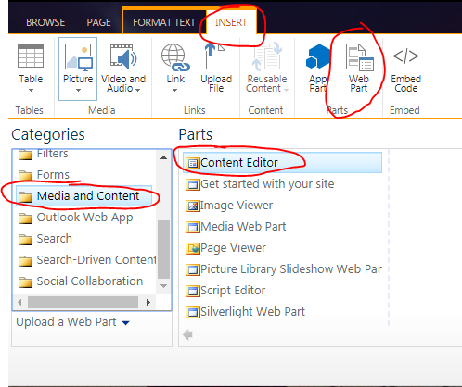

* 1. Click edit Web Part
  2. 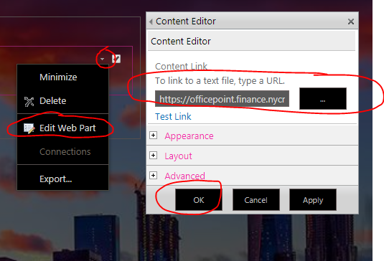In the Content Link Section, paste the following URL and click OK: ../SiteAssets/HillsbillyTabs2.js
  3. Now, insert as many lists/libraries as needed as discussed above

# Adding Pictures to a Page

1. Adding Pictures to a page
   1. There are two ways to add pictures: as thumbnails or as a slideshow. In either case, the pictures must be uploaded to a picture library first
   2. Thumbnails
      1. Go to Page🡪Edit🡪Insert🡪 App Part
      2. Find the Photo Library you wish to add
      3. 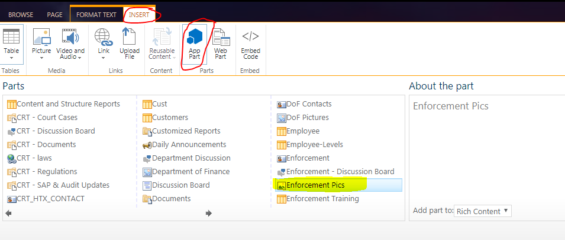Click Add
   3. To Add a slideshow
      1. Go to Page🡪Edit🡪Insert🡪 Web Part 🡪Media and Content 🡪Picture Slideshow and click Add

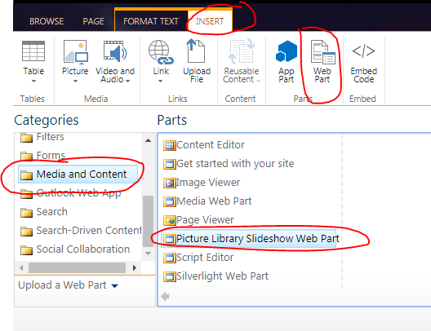

* + 1. Click Edit Web Part
       1. From the Picture Library Dropdown, choose the picture library you wish to display
       2. 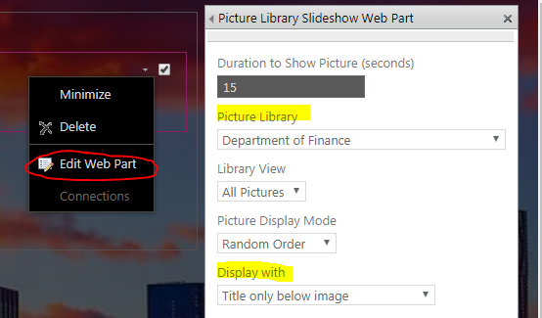Under the Display With Dropdown, choose Title and Caption Below Image
    2. In the Title Option, choose a title for the slideshow. If you do not want a title, enter a single space ( ) in the box

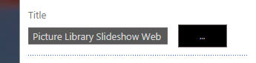

* + 1. Then click OK to finish

# Adding Videos to a Page

1. To add videos to a page
   1. Open up the asset library containing the videos in a new browser tab
   2. Open the page you want to add the videos to in a second browser tab
   3. Click Page 🡪 Edit
   4. 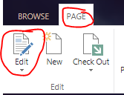Click Insert 🡪 Video 🡪 From address
   5. 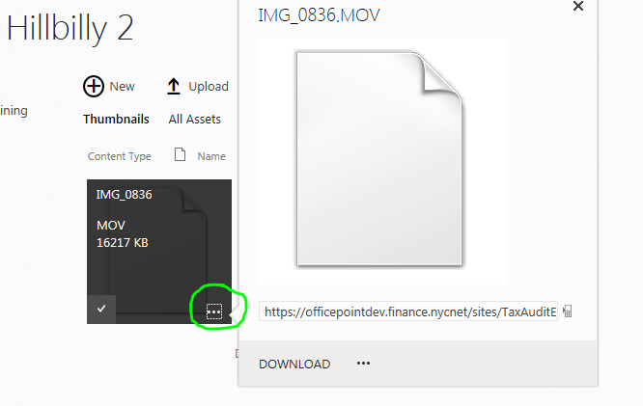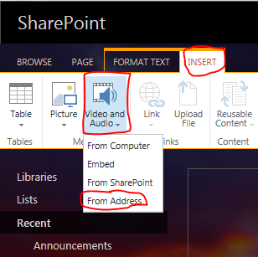From the asset library in the other browser tab, click the 3 dots to see the video URL.
   6. Copy & paste URL into the Link Media Box

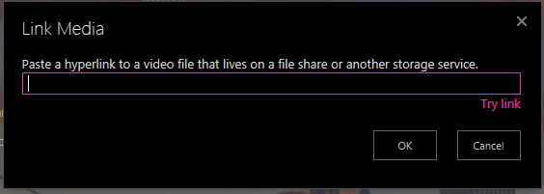

# Adding Tabs to the Top Navigation Bar

1. To Add Tabs to the top navigation bar
   1. Copy the URL of the page to be added
   2. Go to Settings 🡪 Site Settings 🡪 Navigation
   3. Scroll down to structural navigation

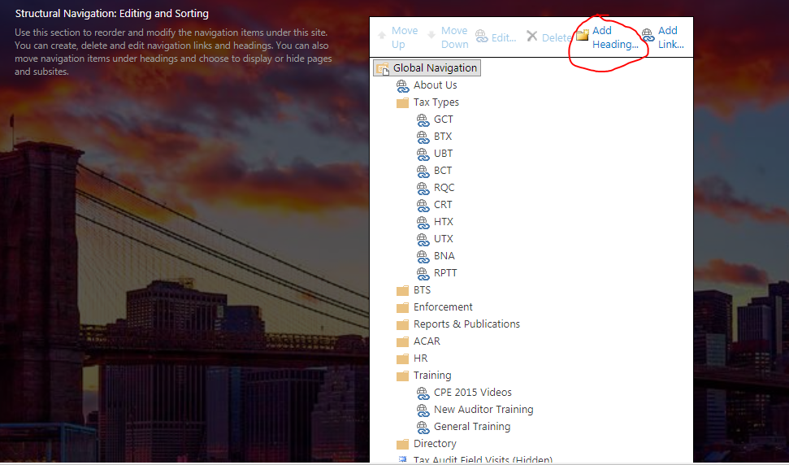

* 1. Click Add Heading to add a new Tab to the top bar
     1. You will be asked to input the Title of the Tab
     2. If you want the tab to be “click-able” enter the URL of the page beneath it
     3. 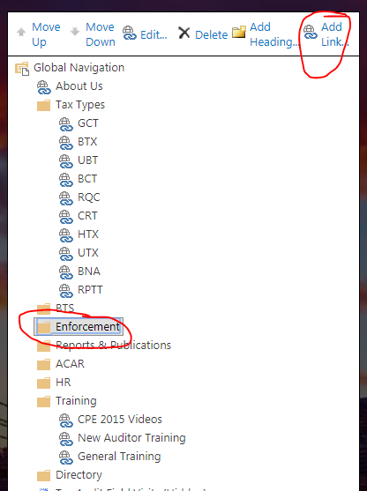If you do not want the tab to be “click-able” do not enter a URL
  2. To add a dropdown feature, click a header and then click add link
  3. Input the name and URL of the site for the dropdown
  4. Use the “Move Up”/ “Move Down” buttons to change the order of the tabs

# Dealing with Metadata

Changing the view changes what metadata (body, modified date, modified by, etc.) can be seen by the user

1. To Change the view of a library or list
   1. Find the library/list on the page where you want to change the view
   2. Click Library(List) in the top ribbon and then click Modify View

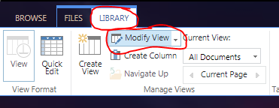

* 1. In the Columns Section, choose what columns to display
  2. If you want the list/library sorted, Under Sort, choose a value to sort the library/list by
  3. If you want to group list/library contents, Under Group, choose a value to group the library/list by
  4. Then click OK

# Updating What’s New

1. How to update What’s New
   1. Upload pictures to picture library & videos to asset library
   2. Create a page for the event
   3. On the new Page: insert the pictures as thumbnails and/or videos as needed
      1. 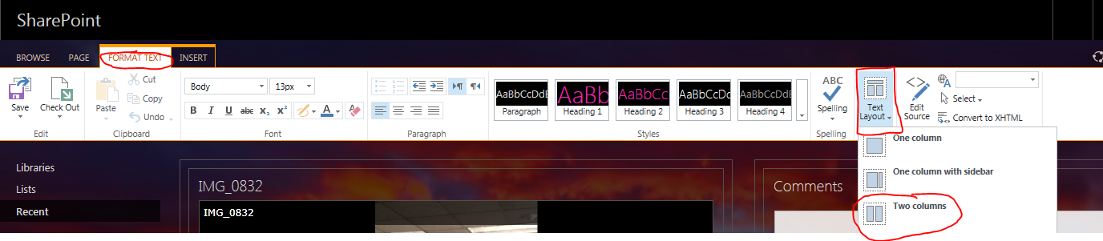When uploading videos, it is helpful to change the text layout to two columns. This allows for 1 column for videos and 1 column for the comments. This can be done from the top ribbon. Click Page🡪Edit🡪Format Text🡪Text Layout🡪Two Columns
   4. 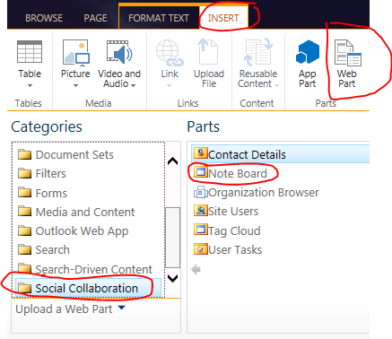Once the media content is uploaded, click within the text box area (If the page has videos on it, click within the second column on the right side) and then select a Note Board Web Part from Page🡪Edit🡪 Insert 🡪Web Part🡪 Social Collaboration 🡪Note Board. Then click Add
   5. 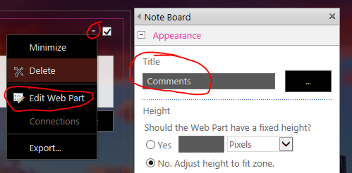Click Edit Web Part and change the name to “Comments”. Then click OK and save page
   6. Copy the URL of this page
   7. Go to the What’s New Page and click New Announcement
   8. Give the Announcement a title
   9. In the body section, click within the box then click Insert 🡪 Link 🡪From Address
   10. Paste the URL in the address bar
   11. Type “Click here to view pictures/videos” in the Text to Display Box
   12. 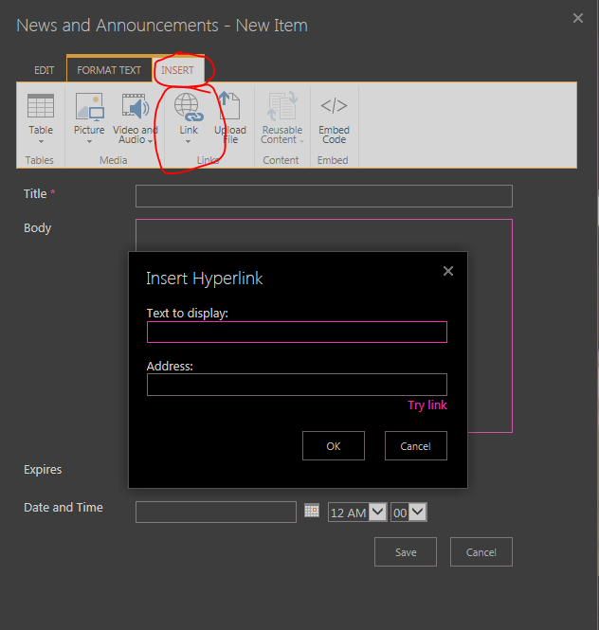Input the date of the event so that the list can be sorted chronologically

# Adding Alerts

1. Adding Alerts
   1. 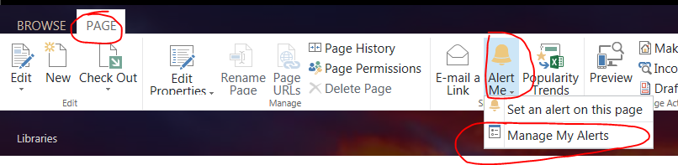Click the Page Tab 🡪Alert Me 🡪Manage My Alerts
   2. 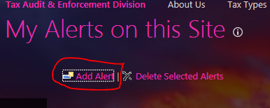Click Add Alert
   3. Click the button next to the library/list you need to add alerts for and then click next on the bottom of the page
      1. Alerts must be added one at a time. There is no mass alert creation feature
   4. In the “Send Alerts To” box, enter the names of everyone that will receive this alert. Copy these names from the TXT file which is on SharePoint

e. Click OK to create the alert. All users will receive an initial subscription alert that tells them that they have been subscribed to an alert

**Note: Any modification of any kind using the top ribbon or click the (…) button will send out an alert. This includes changing font or font colors, viewing properties etc. Any change, however small, sends an alert UNLESS the change is made with a Script Editor. Then no alert is sent.**

**For mass uploading of documents, please have Mr. Erik Javier send out a mass email t othe affected users apologizing for the influx of email alerts**

# Deleting Alerts

1. Removing Alerts
   1. 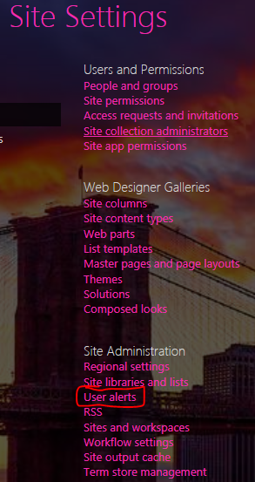Go to Settings🡪Site Settings🡪User Alerts

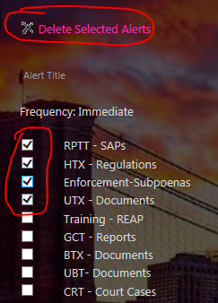

* 1. From the dropdown list, select the user whose alerts you wish to modify and click Update
  2. Check the boxes to select the alerts
  3. Then Click Delete Alert

**Note: This must be done individually for all users. There is no mass delete feature**

# Adding Keyword List

1. To create a Keywords column in a list/library
   1. Go to Settings🡪 Site Contents and select the list/library in question
   2. 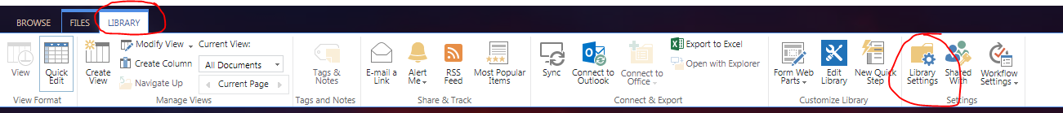In the top bar, click Library (List) and then Library (List) Settings

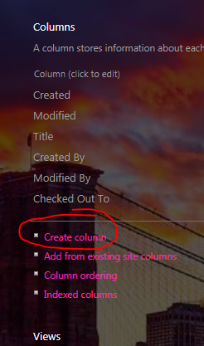

* 1. Scroll down and click Create Column in the Column section
  2. Enter the Column name (Keywords). Column Type is single line of text. Then click OK. Next, go back to the library.
  3. 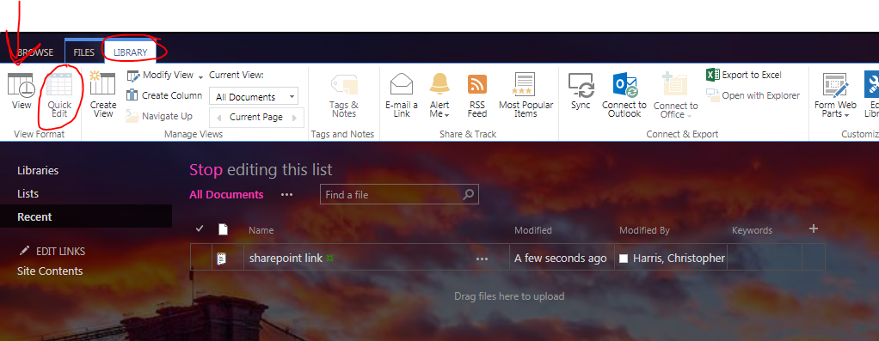To Input the Keywords, click Library (List) and then Quick Edit. This turns on Excel- like editing features
  4. Simply type the Keywords in the cell, separating them with a comma (,)
  5. And then click View on the top Ribbon to end edit mode

# Creating a Custom Search for Keywords

1. Create a New Page
2. Add a Search Box and Search Results Web Part from Page🡪Edit🡪Insert🡪WebPart🡪Search. The Web Parts must be added individualy 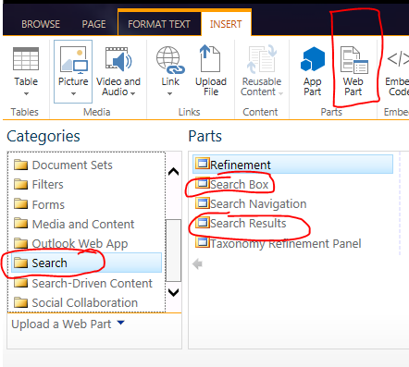
3. 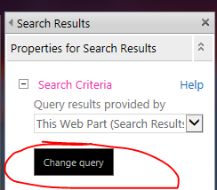Edit the Search Results Web Part and select Change Query
4. 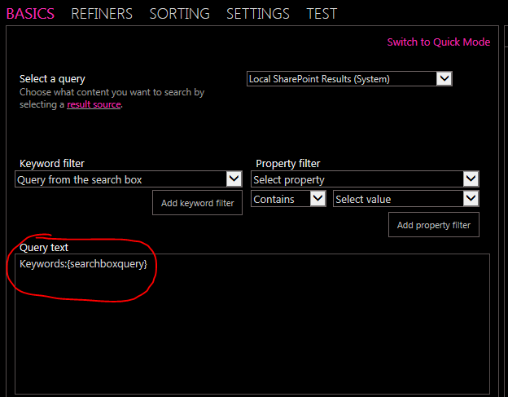 Under the Basics Tab, in the Query Text Box, type “Keywords:” (without the quotes) as shown in the picture then click OK
5. Any words typed into the search box will be treated by SharePoint as if the user had typed “Keywords:” in front of it
6. Click OK in the Web Part menu and then save the page

The way this setup is currently configured is as follows: This search box allows users to search on keywords without having to type in “Keywords:” before the actual keyword. There is no link anywhere for users to navigate to this page. Instead, a keyword search list is created for each unit. This list has two columns: the keyword and a link to search for documents with this keyword. The search term is appended to the search box URL so that when a user clicks on it, the search is completed automatically. Refer to the UBT Tab: Keyword Search for an example.

This feature should not have to be recreated again. The explanation is here just in case it stops working.

# Creating a Keyword Search List

1. Go to Settings🡪 Site Contents and click the list/library you want to edit
2. Click List/Library Settings in the top ribbon for the list you want to add Keyword Search for
3. Click create column
4. 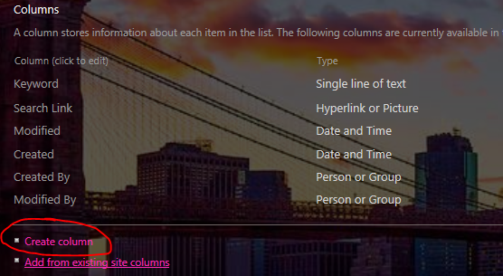Name the column Search Link
5. Column Type is Hyperlink/Picture. Click OK and then return to the list/library.
6. 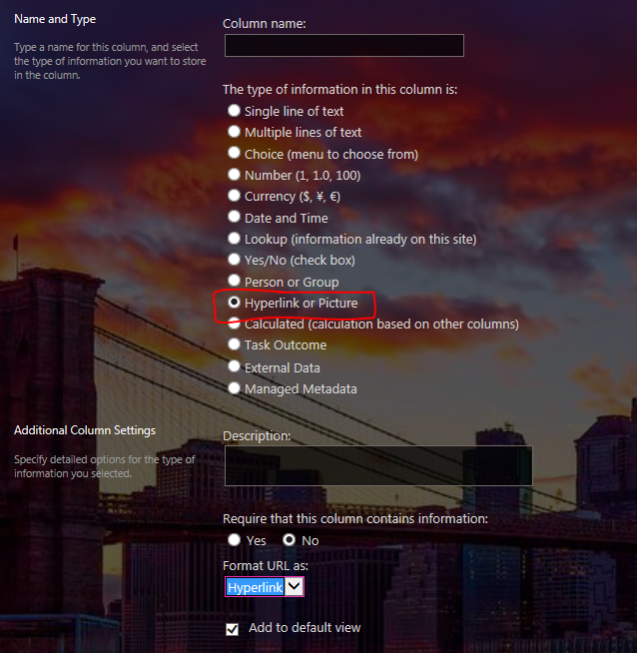To modify the column, first click the Library Tab. Then click Quick Edit. Then click in the search link cell you wish to edit. Then click the image of a Globe and Chain
7. 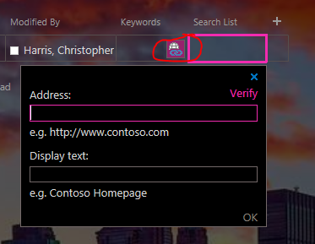In the address box, paste the following link with one modification: at the end of the link, change XXXXXXX to the Keyword you wish to search on <https://officepoint.finance.nycnet/sites/taxauditandenforcementdivision/SitePages/Keyword%20Search.aspx#k=XXXXXXXXX>
   1. For example, if you want to search for the Keyword *Audit*, the URL would look like

https://officepoint.finance.nycnet/sites/taxauditandenforcementdivision/SitePages/Keyword%20Search.aspx#k=***Audit***

1. In the Display text box, type: Click here to search
   1. Refer to the UBT Keyword Search Tab
2. Then click OK
3. Repeat steps 6-9 for all keywords
4. When you are finished, Save the page from the top ribbon

# Dealing with CSS

1. In the Site Assets Library, there is a CSS file called Core3. This is the alternate CSS file that is used by all pages of the TA&E SharePoint site. It contains CSS code for elements that are common to all pages, such as the search bar and navigation features. Script editors must be used on each page to modify what Core3 does not.
2. 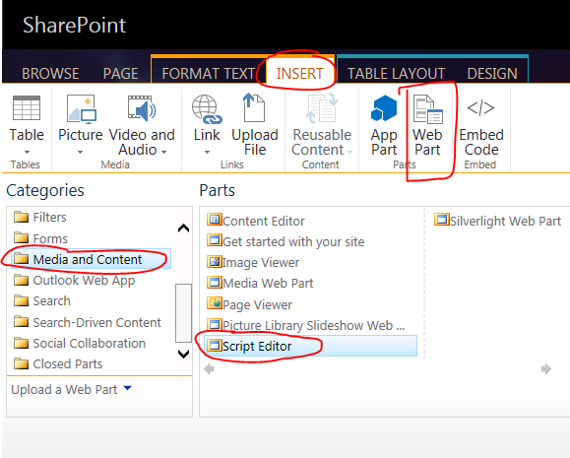To Insert a Script Editor, click Page 🡪Edit 🡪Insert 🡪Script Editor. You must edit the Web Part to insert a script
3. On SharePoint, there is a Word Doc that has all the CSS scripts used on the site. It is broken down by what page it is on and what its function is. Refer to this document for all CSS changes.
4. How to modify the CSS Scripts:
   1. Color: The color can be changed in 2 ways
      1. Type in the name of the color, without a preceding #
      2. Type in the 6 Digit Hex Color Code with a preceding #
   2. Font-Size: change the number to change font size. Be sure to follow it with px
5. Using F12
   1. 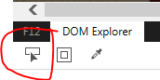Pressing F12 brings up the developer tools for a website
   2. Click this button to bring up an interactive display
   3. Click any element to see the HTML for the site and find the name of the section that contains the CSS that needs to be modified
   4. Any changes to HTML/CSS made in Dev Tools are **NOT** permanent. It is just a way to try various colors/fonts to see what looks good. Only changes in the script editor will persist on the site.

# Adding Announcements

1. Go to the Announcements Tab, then click New Announcement
2. Fill in all fields: Title, Body, Date and Time and Small Description. Small description is a 1 line blurb that will appear on the homepage. Click Save to publish the announcement and send out an alert

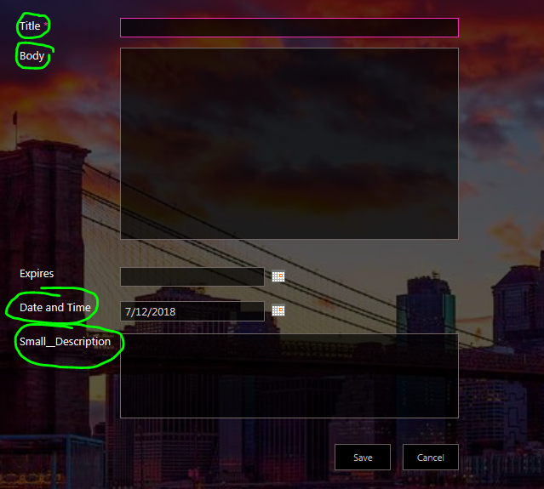

# Adding and Removing Events on the Calendar

1. There are two Calendar Web Parts on the Homepage. One is a traditional calendar with boxes. The other is a detailed description box. Adding an event to one will create the event on the other. The purpose of the detailed box is to make the information about an event easier to read for the user
2. To Update the Traditional Calendar
   1. Click in the box where the event goes and then click Add Event

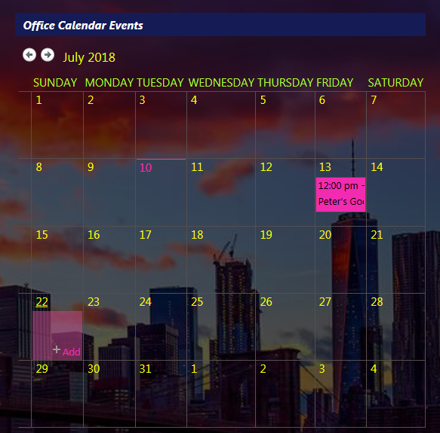

* 1. 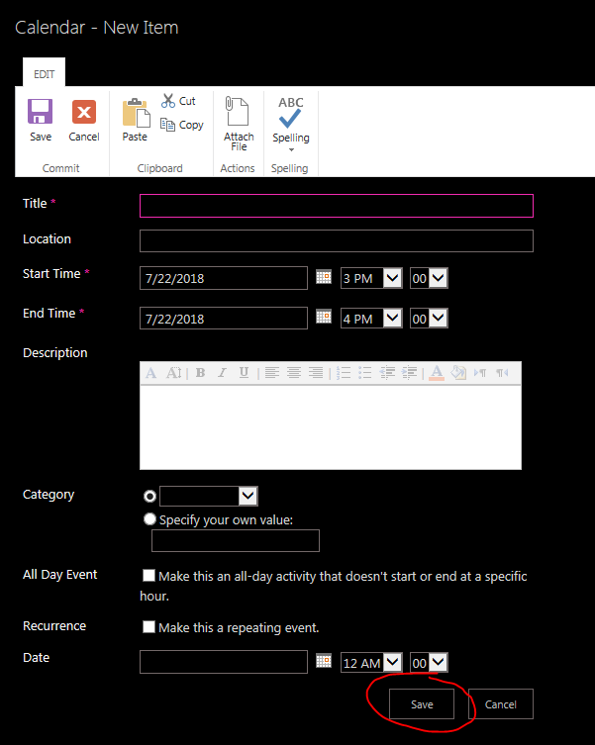Fill out the form that pops up and then click Save
  2. The event will appear in the box and in the list view

1. 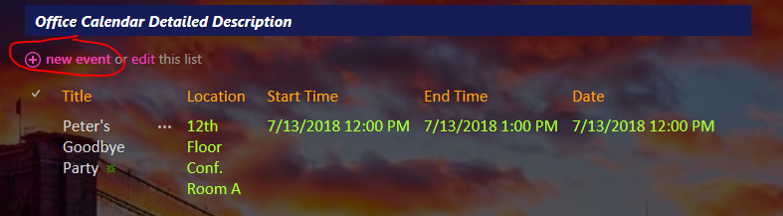To Update the List
   1. Click New Event
   2. Fill out the form that pops up and hit save

Note: Events will not be automatically deleted from the calendar once the date has passed. They must be manually removed

To do this, click the three dots in the list view, and then click Delete Item 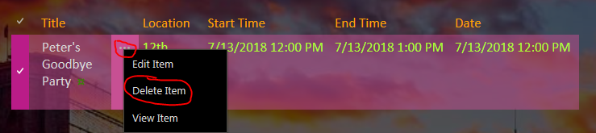

# Creating Groups

1. 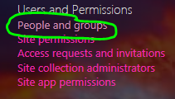Go to Settings 🡪 Site Settings 🡪 People and Groups
2. Click the More option at the bottom of the left sidebar
3. 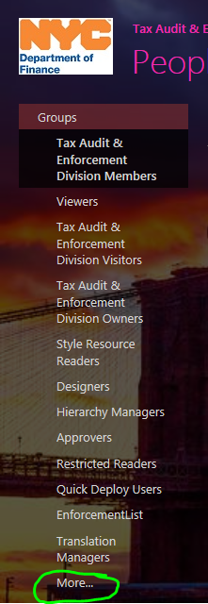Click New
4. Name the group, choose an owner, and then click Create at the bottom of the page
5. Now you must add members to the group. Click New at the top
6. 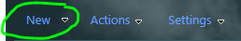Input the names of the people to be added to the group and click Share

# Creating Custom Permissions for a Library

1. Create a group as discussed above
2. Go to Site Contents and then click the Library/List you wish to change the permissions for
3. Click List/Library in the top bar then click List/Library Settings 
4. 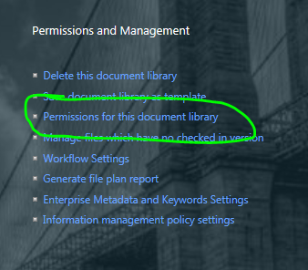Click Permissions for this Document Library
5. Click Stop Inheriting Permissions in the top bar. If a popup appears, click OK
6. 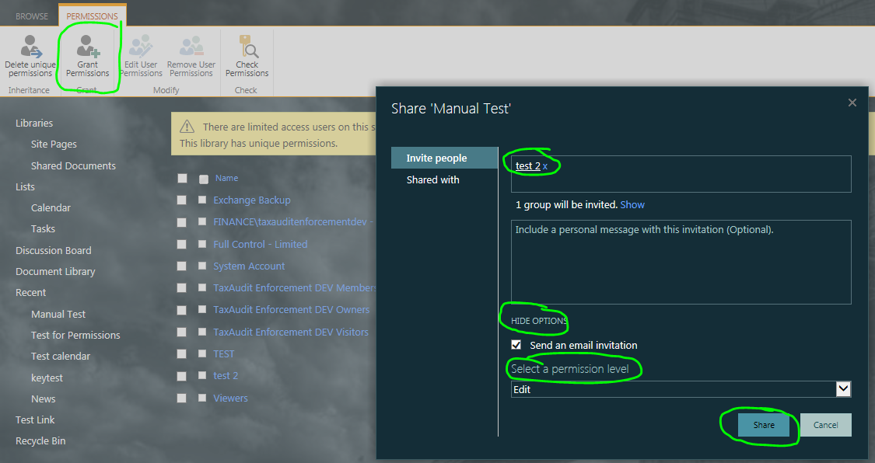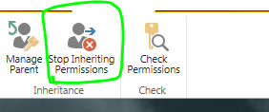Click the Grant Permissions Box in the top ribbon. Then type the name of the group into the box. Click show options and choose an access level for the group. When you are finished, click Share
7. 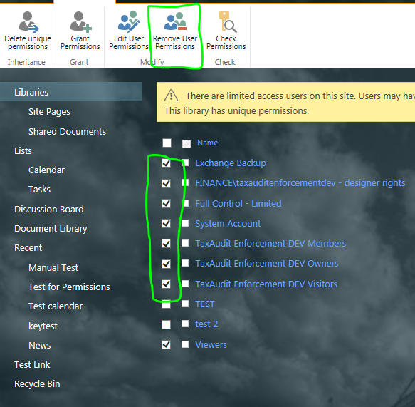Now, check the box next to all the groups EXCEPT for the one you just added. Then click Remove User Permissions in the top box

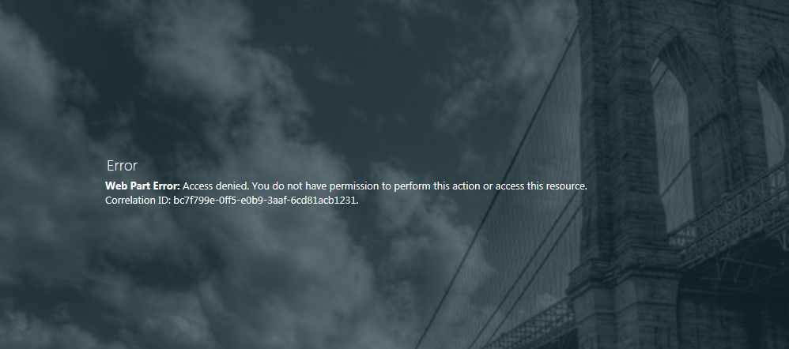A user who does not have access to a library or list will see an error message of that library/list is on a page. Only users with access can see the contents of the library.

# Setting a Target Audience

1. First, create a group as discussed above, as well as any libraries or lists as needed
2. When you create a document library, there is an additional step you must take to keep the documents from appearing on the Home Page in the Recent Updates Web Part
   1. Go to the library, then click library settings, then click advanced settings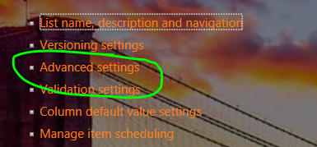
   2. Scroll Down until you see the Search section. Make sure the NO button is checked. Then click OK 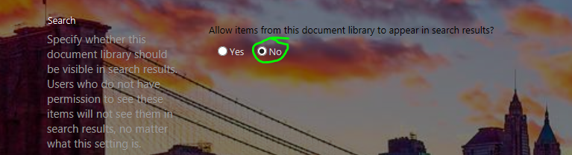
3. 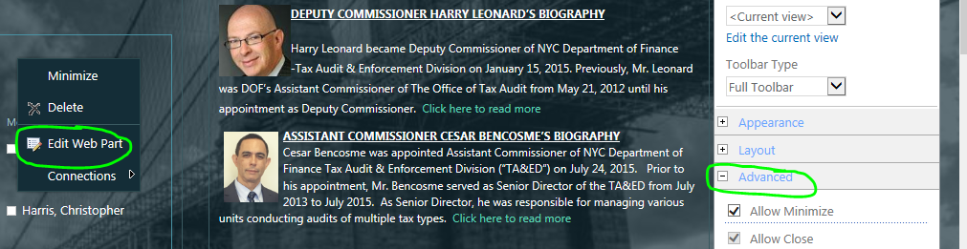Go to the page where the List/Library or Web Part is
4. Click Page🡪Edit. Then click Edit Web Part and scroll down to the Advanced Tab
5. 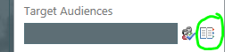Under advanced is an option that says Target Audiences. Click the Book icon next to the box
6. 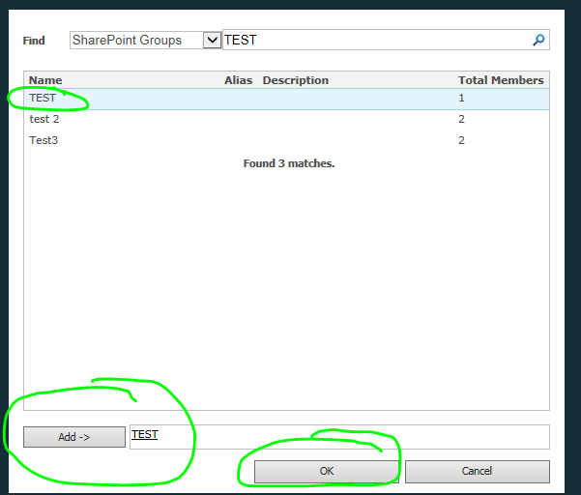Change the dropdown so it says SharePoint Groups
7. 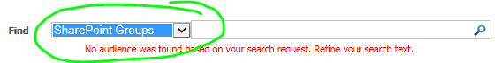Type the name of the group in the search box and click the magnifying glass
8. Click the name of the group in the list, then click Add, and then click OK
9. Once you are back on the page, click OK in the Web Part menu and click Save in the ribbon
   1. A user who is not in the Target Audience group does not see anything if the list/ library is on a page

# Configuring the Recently Uploaded Documents Web Part

1. 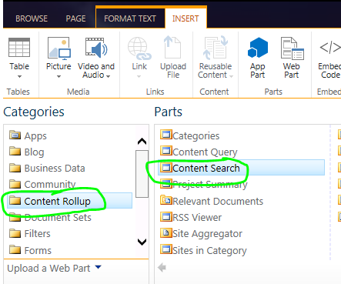On the home page, the Recently Uploaded Documents Web Part is actually a Content Search Web Part
2. Go to Page🡪Edit🡪Insert🡪Web Part 🡪 Content Rollup 🡪 Content Search
3. 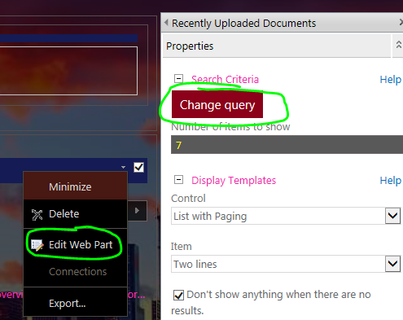Edit the Web Part and click Change Query
4. In the Select a Query dropdown, choose Documents
5. 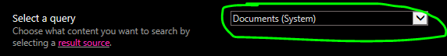Next click Advanced Mode and then Sorting
6. 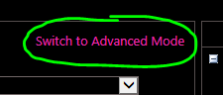In the Sorting page, choose Created from the dropdown and set the option to Descending then click OK

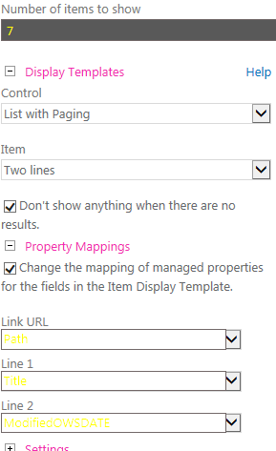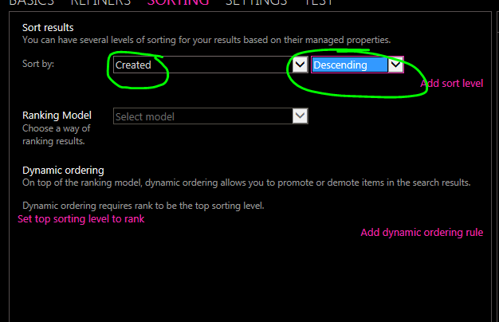

1. Back in the Web Part Options, you can choose display settings. You can modify the number of results to show, how they are shown, and what information is displayed for each document

# How to Change the Overall Color Theme

1. Go to Settings 🡪 Site Settings 🡪 Change the Look
2. Click Change the Look
3. Click Current
4. 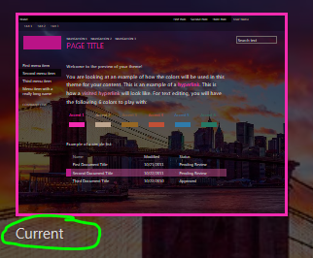The Left Sidebar has all the options that can be modified.
   1. Choose a new color scheme from the dropdown
5. Click Try it Out to see a preview of the homepage
6. Then choose Yes or No to keep or discard changes



Note: Changing the color theme will also affect the background filter overlay

# To Change the Background to a Picture

1. In Core3, there is a section called .ms-backgroundImage. Inside this section there is an element called background: url (“……..”). The URL inside the parentheses is the URL for the background image inside of Site Assets.
2. To Change the background, first select and upload a picture to Site Assets. Then copy the URL for it
3. Download and open the core3 CSS file. Find the section that controls the background as discussed in Step 1.
4. Replace the old URL with the new one and save core3.
5. Upload core3 to Site Assets
6. The background image will now change

# To Change the Background to a Color Gradient

1. In Core3, there is a section called .ms-backgroundImage. Inside this section there is an element called background: url (“……..”).
2. Download core3 from Site Assets. Find the section discussed in Step 1
3. Delete the background: url line
4. Paste in this:
   1. background-image: linear-gradient(to top, #a18cd1 , #fbc2eb);
5. This code will set a color gradient to be the background
   1. The “to top” section controls what direction the gradient will flow,
      1. To bottom, to left, to right are also valid options
   2. The first Hex code is the starting color
   3. The second hex code is the ending color
   4. Both can be changed to be any hex code
6. Save core3 and upload it to Site Assets

# To Move Videos off the G Drive

1. Open the G Drive. Navigate to Audit and Enforcement SharePoint 🡪 Project Documents 🡪Training Videos. The CPE Folder has the videos for the CPE 2015 Dropdown. Week 1 and Week 2 are the folders for the New Auditor Training Videos
2. Create Asset Libraries to hold the videos
3. Download the three folders to your computer. Then, upload each video individually to SharePoint in the appropriate Asset Library. Repeat for all videos
4. Once all videos are uploaded, create a page to hold the videos.
5. Now, insert the videos to the page, keeping the same format as the existing CPE/New Training Videos
6. Once all videos are moved & the site still functions & Erik approves it, delete videos from the G Drive. (Possible flash drive backup?)